**[Unit 1] Business Intelligence Introduction [6 Hours]**

Definition, History of Business intelligence, Leveraging Data and Knowledge for BI, BI Components, Business Intelligence and Business Analytics, BI Life Cycle, Business intelligence architectures, Effective and timely decisions.

Question:

1. **Define: (L1: Rember)**
2. **Business Intelligence**
3. **Business Analytics**

**Or**

**1) Describe Business Intelligence and Business Analytics**

**2)Discuss The History of Business intelligence (L2:Understant)**

**3)Describe Leveraging Data and Knowledge for BI(L2:Understant)**

**Or**

**3)Summarize data,Information and Knowledge?**

**4)Explain the BI Components (L2:Understant)**

**5)Differentiation Business Intelligence and Business Analytics (L2:Understant)**

**6)Describe BI Life Cycle : (L2:Understant)**

**7) Explain Business intelligence architectures (L2:Understant)**

**8)Summarize Effective and timely decisions on** **Business intelligence (L2:Understant)**

**[Unit 2] BI Planning for success [6 Hours]**

The role of mathematical models, Enabling factors in business intelligence projects, Development of a business intelligence system, Ethics and business intelligence, Planning for Success: Initiating a Program, Business/Information Technology Partnership, Business Intelligence Success Factors, Team Building, Strategic versus Tactical Planning.

**1)Illustrate/Use The role of mathematical models ?** L3:Apply

**2)Determine the Enabling factors in business intelligence projects ? L3:Apply**

**Or**

**2)Examine Business intelligence project technology, analytics and human resources?**

**3) Examine the Development of a business intelligence system? (L2:Understant)**

**Or**

**3)Examine Phases of development of business intelligence system?** L3:Apply

**4)Show importance of Ethics on business intelligence?** L3:Apply

Or

4) **Apply Ethics on business intelligence?**

**5)Determine success plan for business intelligence?** L3:Apply

Or

5)**Describe in detail the Planning for Success for business intelligence?**

**Or**

**5)Determine the program need to Initiating for Success for business intelligence?**

**6) Examine Business/Information Technology Partnership? L3:Apply**

**7)Determine/calculate Business Intelligence Success Factors ? L3:Apply**

**8)Illustrate Team Building for business intelligence solution? L3:Apply**

**or**

**8) Determine team selection/Building ideas for business intelligence solution? ? (L2:Understant)**

**9)Examine Strategic versus Tactical Planning? L3:Apply**

**Or**

**9)Discuss Long and Short-Term Goal for business intelligence?**

**[Unit 3] Decision support system [6 Hours]**

Definition of system, Representation of the decision-making process, Rationality and problem solving, The decision-making process, Types of decisions, Approaches to the decision-making process, Evolution of information systems, Definition of decision support system, Development of a decision support system

**1)Analyze Definition of system?** L4(Analyze)

Or

**1)Classify Abstract representation of a system?** L4(Analyze)

Or

**1)(3m) Outline Closed Cycle System with and example?** L4(Analyze)

2)Describe the Representation of the decision-making process? L2 **Understand**

**3)Analyze Rationality and problem solving for Decision Making process?** L4(Analyze)

**4)Classify the Phases of the Decision-Making process?** L4(Analyze)

**5)Outline Type of Decision?** L4(Analyze)

**6)Examine the Approaches for Decision Making process? L3:Apply**

**7)Describe Evolution of information systems? ? (L2:Understant)**

**4) Definition of decision support system?L1 rember**

**5) Illustrate Structure of decision support system? L4(Analyze)**

**5) Illustrate Extended Structure of decision support system? L4(Analyze)**

**6)Diagram with explanation of Development of a decision support system?**

**[Unit 4] Data Warehousing [6 Hours]**

Definition of data warehouse, Data marts, Data quality, Data warehouse architecture, ETL tools , Metadata, Schemas Used in Data Warehouses: Star, Snowflake and fact constellation , Cubes and multidimensional analysis ,Hierarchies of concepts and OLAP operations ,OLAP vs OLTP Materialization of cubes of data

1. **Definition ((L1: Rember)**
2. **Data Warehouse**
3. **Data marts**
4. **Data quality**
5. **ETL tools**
6. **Metadata**

**2)Describe Definition of data warehouse (L2:Understant)**

**3)Explain Data warehouse architecture (L2:Understant)**

**4)Describe Schemas Used in Data Warehouses (L2:Understant)**

**5)Summarize Cubes and multidimensional analysis (L2:Understant)**

**6) Describe Hierarchies of concepts and OLAP operations (L2:Understant)**

**7) Differentiation OLAP vs OLTP (L2:Understant)**

**8) Explain Materialization of cubes of data (L2:Understant)**

**[Unit 5] Data Mining and Application of BI [6 Hours]**

Data mining, Definition of data mining, Models and methods for data mining, Data mining, classical statistics and OLAP, Applications of data mining, Representation of input data, Data mining process, Applications of BI:Data Warehousing Helps MultiCare Save More Lives ,Smarter Insurance: Infinity P&C Improves Customer Service and Combats Fraud with Predictive Analytics.

1. **Definition ((L1: Rember)**
2. **Data mining**
3. **OLAP**

**2) Summarize Models and methods for data mining (L2:Understant)**

**3) Applications of data mining L3:Apply**

**4) Examine Representation of input data in Data mining L3:Apply**

**5) Describe** Data mining process **(L2:Understant)**

**6) Explain any one** Applications of BI with Business model? **(L2:Understant)**

**Solution:**

1. **Define:**
2. **Business Intelligence:**

Business intelligence may be defined as a set of mathematical models and

analysis methodologies that exploit the available data to generate information

and knowledge useful for complex decision-making processes

Wiki:

Business intelligence (BI) comprises

the strategies and technologies used by enterprises for the data analysis and management of business information.

Common functions of business intelligence technologies:

* include reporting,
* online analytical processing,
* analytics, dashboard development,
* data mining,
* process mining,
* complex event processing,
* business performance management, benchmarking, text mining, predictive analytics, and prescriptive analytics.

1. **Business Analytics**

A subset of BI, business analytics (BA) refers to the process of taking your company’s raw data and turning it into useful information, including identifying trends, predicting outcomes, and more. Some common methodologies in business analytics are:

Data mining: sorting through large amounts of data to identify patterns and trends

Aggregation: the process of gathering and organizing data prior to analysis

Forecasting: analyzing historical data estimate future outcomes

Predictive modeling: extracting information from data sets to identify patterns and estimate future trends

Data visualization: creating visual representations of data analysis, such as charts, tables, or graphs

**2)Discuss The History of Business intelligence (L2:Understant)**

The first written record that we have of the term ‘business intelligence’

comes from Richard Miller Devens’ 1865 work Cyclopaedia of Commercial and Business Anecdotes.

Sir Henry Furnese, was an English merchant and Whig politician who sat in the English and British House of Commons between 1698 and 1712. was master of the Drapers' Company from 1694 to 1695. He was one of the original directors of the Bank of England when the bank was founded in 1694 a banker, profited from information by gathering and acting on it before his competition.

**1950’s – Start of the Digital Revolution:**

* In 1956 IBM invented the hard disk, which at the time had 5MB of memory storage and with its
* gigantic dimensions weighted over a ton
* landmark is particularly relevant to BI as it gave way to the replacement of physical filling systems for digital ones.
* However, it was not until July 1958 that a new milestone for BI took place in the United States.
* Introduction of Decision Support Systems (DSS)
* Role in Assisting Managers' Decisions
* 1958, an article was written by an IBM computer scientist
* named Hans Peter Luhn, describing the potential of gathering business intelligence (BI) through the use of technology.

**1960’s – Early computers & databases**

* dramatic increase in the introduction and use of computers.
* Created in the early 60’s, the first electronic calculator was able to perform the work of 50,000 people working by hand.

**1970’s – The first BI vendors**

* First BI vendors (SAP, Siebel and JD Edwards, the last two now part of the Oracle Corporation),
* tools became available to help accessing and organizing data in more effective ways.
* it's a key component of Oracle's customer experience (CX) and industry solution strategy. Utilize a complete, enterprise grade CRM solution
* ERP (or Enterprise Resource Planning) software.
* Emergence of Online Analytical Processing (OLAP)
* Exploring Multidimensional Data

**1980’s – Birth of data warehouses**

* Introduction to Data Warehousing
* Importance of Consolidating Data
* Role of Data Mining in Extracting Insights

**Executive Information Systems (EIS) in the 1980s**

* Development and Purpose of EIS
* Providing Real-Time Data to Senior Management

**1990’s & 2000’s: Business Intelligence 1.0 and Business Intelligence 2.0**

* most popular was Enterprise Resource Planning (ERP), which is a management software that integrates applications to manage and automate aspects of a business.
* 2000’s (known as Business Intelligence 2.0) added more speed to BI development and saw a concentration of BI in the hands of IBM, Microsoft, SAP and Oracle.
* [By 2010](https://cdn.sisense.com/wp-content/uploads/Analytics_History_Infographic-1.jpg), 35% of enterprises use pervasive BI and 67% of “best in class” companies have some self-service BI.

**2010 – Present day**

* Today we are in the 3.0 stage of BI.
* BI has become a standard tool for every medium or large enterprise, from finance and banking to IT and communications.

**3)Describe Leveraging Data and Knowledge for BI(L2:Understant)**

Leveraging data and knowledge for Business Intelligence (BI) is crucial for organizations

looking to make informed decisions, gain a competitive edge, and improve overall

performance. BI involves the process of collecting, analyzing, and transforming data into

actionable insights. Here are key steps and strategies to effectively use data and knowledge for

BI:

**Data Collection**:

Identify relevant data sources: Determine which data sources are essential for your

organization, such as databases, spreadsheets, CRM systems, social media, and external data

providers.

**Data integration**: Integrate data from various sources into a centralized data repository to

create a single source of truth.

**Real-time data:** Consider real-time or near-real-time data collection for up-to-the-minute

insights.

**Data Cleaning and Preparation:**

Cleanse and preprocess data to ensure accuracy and consistency.

Handle missing data and outliers appropriately.

Normalize or standardize data to make it suitable for analysis.

Data Storage:Choose an appropriate data storage solution, such as data warehouses, data

lakes, or cloud-based storage.Ensure data security and compliance with data privacy

regulations.

Data Analysis:Select BI tools and platforms that suit your organization's needs. Popular

choices include Tableau, Power BI, and QlikView.Create dashboards and reports to visualize

data trends, KPIs, and performance metrics.Use advanced analytics techniques like predictive

analytics and machine learning to uncover hidden insights.

**Knowledge Management**:Develop a knowledge management system to store and organize

insights, reports, and best practices.Encourage data sharing and collaboration among teams.

Document data sources, definitions, and data lineage to maintain transparency.

**Business Intelligence Strategy:**

Define clear business objectives and key performance indicators (KPIs) to measure success.

Align BI initiatives with overall business goals.Establish a governance framework to manage

data quality, security, and access.

**User Training and Adoption**:Train employees on BI tools and best practices.

Foster a data-driven culture by encouraging data literacy and awareness.

Ensure accessibility and usability of BI solutions for non-technical users.

**Continuous Improvement**:Monitor and evaluate BI performance regularly.

Gather feedback from users to refine reports and dashboards.

Stay updated with emerging BI technologies and trends.

**Data Security and Compliance:** Implement robust data security measures to protect sensitive

information.Ensure compliance with data protection regulations like GDPR, HIPAA, or CCPA.

**Collaboration and Communication**: Promote collaboration among different departments and

teams by sharing insights and findings.

Use storytelling techniques to convey data-driven narratives that are easy to understand.

Leveraging data and knowledge for BI is an ongoing process that requires a combination of

technology, people, and processes. When done effectively, it can provide organizations with a

competitive advantage and support data-driven decision-making at all levels.

**4)Explain the BI Components**

* **OLAP (On-line analytical processing):**
* software technology you can use to analyze business data from different points of view.
* multidimensional, summarized views of business data and is used for reporting, analysis, modeling and planning for optimizing the business.
* Ex: forecasting,SAAS
* Advanced Analytics: it is referred to as data mining, forecasting or predictive analytics, this takes advantage of statistical analysis techniques
* Corporate Performance Management (Portals, Scorecards, Dashboards): this general category usually provides a container for several pieces to plug into so that the aggregate tells a story. For example, a balanced scorecard that displays portlets for financial metrics combined with say organizational learning and growth metrics

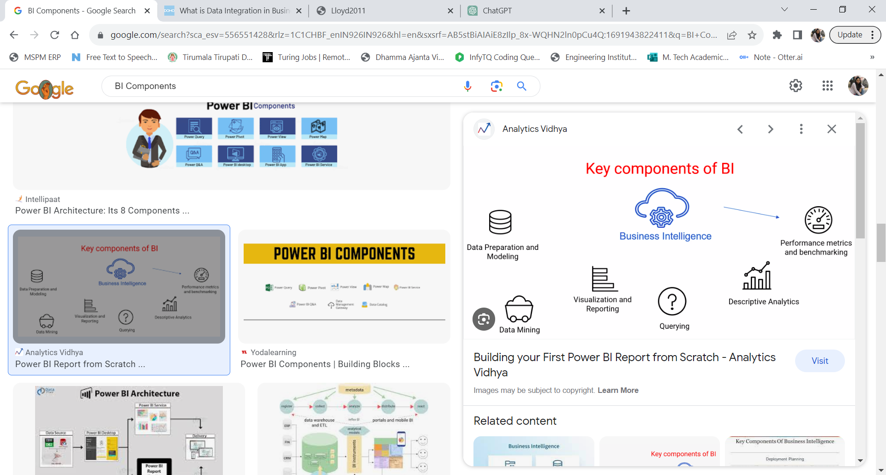

* Real time BI: It allows for the real time distribution of metrics through email, messaging systems and/or interactive displays
* Data Warehouse and data marts: The data warehouse is the significant component of business intelligence
* It involves storage of large amounts of data to the benefit of different divisions of an organization.
* A data mart as described by (Inmon, 1999) is a collection of subject areas organized for decision support based on the needs of a given department.
* **Data sources** :can be operational databases, historical data, external data for example, from market research companies or from the Internet), or information from the already existing data warehouse environment.
* This involves taking raw data and creating systematic data sources with the help of various software applications. BI tools put these datasets to create pie charts, graphs or tables etc.

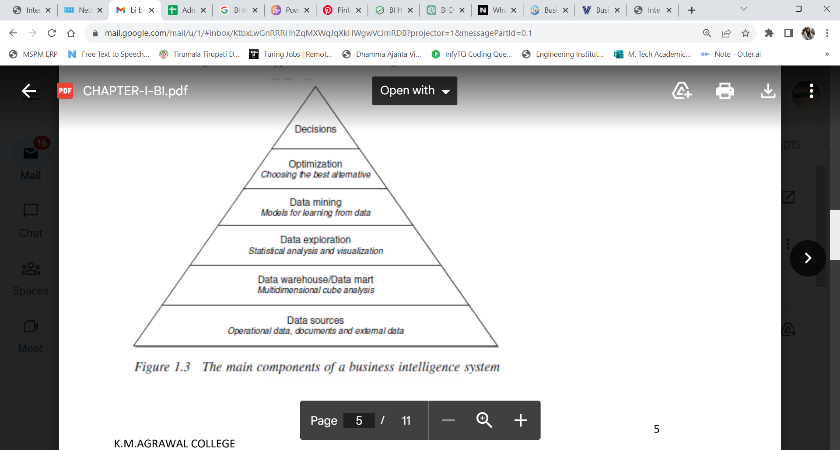

time series analysis;

• inductive learning models for data mining;

• optimization models.

The pyramid in Figure 1.3 shows the building blocks of a business intelligence system. So far, we have seen the components of the first two levels

when discussing Figure 1.2. We now turn to the description of the upper tiers.

**Data exploration**. At the third level of the pyramid we find the tools for performing a passive business intelligence analysis, which consist of query and reporting systems, as well as statistical methods. These are referred to as passive methodologies because decision makers are requested to generate prior hypotheses or define data extraction criteria, and then use the analysis tools to find answers and confirm their original insight.

For instance, consider the sales manager of a company who notices that revenues in a given geographic area have dropped for a specific group of customers. Hence, she might want

to bear out her hypothesis by using extraction and visualization tools, and then apply a statistical test to verify that her conclusions are adequately supported by data.

**Data mining.** The fourth level includes active business intelligence methodologies, whose purpose is the extraction of information and knowledge from data.

**Optimization.** By moving up one level in the pyramid we find optimization models that allow us to determine the best solution out of a set of alternative actions, which is usually fairly extensive and sometimes even infinite. Example 1.2 shows a typical field of application of optimization models.

**Decisions.** Finally, the top of the pyramid corresponds to the choice and the actual adoption of a specific decision, and in some way represents the natural conclusion of the decision-making process. Even when business intelligence methodologies are available and successfully adopted, the choice of a decision pertains to the decision makers, who may also take advantage of informal and unstructured information available to adapt and modify the recommendations and the conclusions achieved through the use of mathematical models

**5)Differentiation Business Intelligence and Business Analytics (L2:Understant)**

**1. Business Intelligence :**

The term Business Intelligence (BI) alludes to advances, applications, and hones for the collection, integration, examination, and introduction of business data. The reason for Commerce Insights is to bolster superior trade choice making. Basically, Trade Insights frameworks are data-driven Decision Support Systems (DSS). Business Intelligence is now and then utilized traded with briefing books, reports and inquiry instruments, and official data frameworks. Business Intelligence frameworks give authentic, current, and prescient sees of commercial operations, most frequently utilizing information that has been assembled into an information stockroom or an information shop and sometimes working from operational information.

**Advantages of Business Intelligence:**

* BI focuses on historical data and trends, allowing managers to identify patterns and insights that can help them make informed decisions.
* BI provides a comprehensive view of the organization’s operations, allowing managers to understand performance across multiple departments and functions.
* BI can help identify opportunities for cost reduction and process improvement, leading to increased efficiency and profitability.

**Disadvantages of Business Intelligence:**

* BI is focused on historical data, which can limitits usefulness in predicting future trends or outcomes.
* BI can be resource-intensive, requiring significant investment in data collection and processing, as well as specialized software and hardware.
* BI can be complex and require specialized skills and training to use effectively.

**2. Business Analytics :**

Business analytics ordinarily refers to the abilities, advances, hones for investigation of past commerce performance to pick up understanding and drive trade arranging. It creates unused bits of knowledge and understanding of business performance based on the information and measurable strategies.

**Advantages of Business Analytics:**

* BA is focused on predicting future outcomes based on historical data, allowing managers to make more accurate forecasts and decisions.
* BA uses advanced statistical and mathematical models to analyze data, providing more precise insights than traditional BI methods.
* BA can help identify opportunities for growth and expansion, as well as potential risks and threats to the organization.

**Disadvantages of Business Analytics:**

* BA is focused on predicting future outcomes, which can be subject to uncertainty and error.
* BA requires significant expertise in statistical analysis and data science, making it more challenging to implement than traditional BI methods.
* BA can be more time-consuming and resource-intensive than traditional BI methods, requiring more sophisticated software and hardware.

**Similarities between Business Intelligence and Business Analytics :**

* Both BI and BA are concerned with analyzing data to provide insghts that can help managers make better decisions.
* Both disciplines involve collecting and processing large amounts of data from various sources, including internal databases, external sources, and social media.
* Both BI and BA use various tools and technologies, such as data mining, data visualization, and predictive analytics, to transform data into actionable insights.

**Difference between Business Intelligence and Business Analytics :**

| **Business Intelligence** | **Business Analytics** |
| --- | --- |
| Examines past and display to drive current business needs. | Analyses past information to drive current business |
| To run current trade operations. | To alter trade operations and move forward efficiency |
| For current commerce operations. | For future commerce operations |
| Tools are SAP Trade Objects, QlikSense, TIBCO, PowerBI etc. | Tools are Word handling, Google docs, MS Visio, MS Office Instruments etc., |
| Apply to all large-scale companies to run current commerce operations. | Applies to companies where future development and efficiency as its objective |
| Comes beneath Business Analytics. | Contains Data warehouse, data administration etc. |
| Key skills for business intelligence are Data collection and Management, Data Stockroom concepts, Understanding of diverse data sources and exchange applications, Domain and business information. | Key skills for business Analytics Get it your objectives, Good verbal communication skills, The capacity to run partner meetings, Be a great listener, Hone your introduction aptitudes. |

**6)Describe BI Life Cycle : (L2:Understant)**

**Phase 1: Analyze Business Requirements**

The first step in the Business Intelligence life cycle is to analyze the business requirements.

The user identifies the business requirements in order to determine the type of analysis that the user then needs to perform.

Identifying the requirements, let the user decides the further action to be performed.

For example, any retail company can analyze the sales data to figure out the products that are top-selling and the products that least sell.

* **Phase 2: Design Data Model**
* Once the requirements are identified the user needs to design the logical model according to the requirements.
* This logical model helps the user to analyze the relationships that exist within the data entities.
* For example, For any retail company, the data model consists of products, their customers, and the sales data
* **Phase 3: Design the Physical Schema**
* Once the logical model is prepared the next step is to design the physical schema using the data model.
* The physical schema describes the structure and the content of the data warehouse.
* For example, in any retail company, physical schema consists of sales-related facts, product-customer relationships, and the sales transactions
* **Phase 4: Build the Data Warehouse**
* Once the logical and physical schema is designed, the next step is to build the data warehouse.
* The design of a data warehouse depends on the physical and logical schema.
* After the design of the data warehouse, the data and the content from the source system are loaded into the data warehouse for further steps.
* For example, for the retail system, designing the data warehouse consists of developing a database that would store the details of customers, products, and other requirements for the business.
* **Phase 5: Create the Project Structure (Metadata)**
* The next step after designing the data warehouse is to create a project structure also known as metadata
* . With the help of this created project structure, the mapping of the tables and data in the data warehouse is easier
* . Creating the project structure describes the further steps and types that need to be implemented.
* **Phase 6: Develop The BI Objects**
* The next step is to develop the BI objects such as metrics, attributes, dashboards, reports, and facts.
* This step consists of developing the reports and dashboards that can be used to analyze the data in the data warehouse.
* For example, the retail company can develop reports and statistics charts that can describe the profit and loss margins.
* **Phase 7: Administer and Maintain the Project**
* The last step is to administer and maintain the project continuously as it undergoes changes.
* The project needs to be monitored to maintain the changes, security, and performance of the system.
* For example, the retail company needs to monitor the reports and statistics accordingly to increase the profit of the sales.

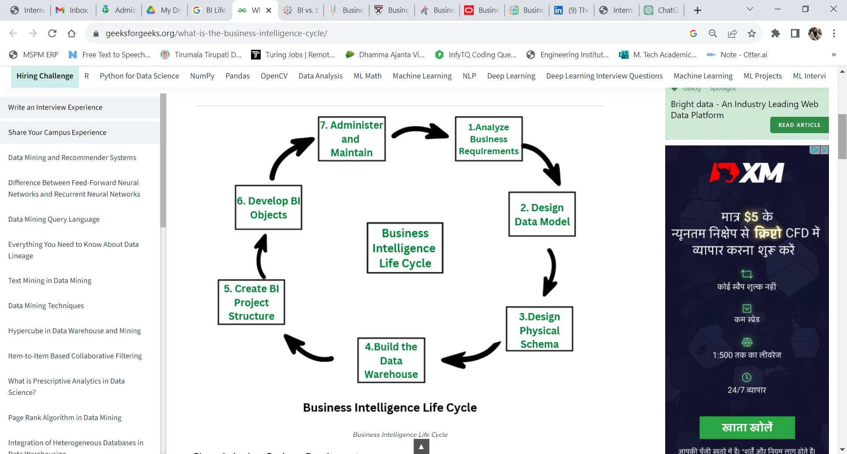

**7)Explain Business intelligence architectures (L2:Understant)**

The architecture of a business intelligence system, depicted in Figure 1.2, includes three major components. Data sources. In a first stage, it is necessary to gather and integrate the data stored in the various primary and secondary sources, which are heterogeneous in origin and type. The sources consist for the most part of data belonging to operational systems, but may also include unstructured documents, such as emails and data received from external providers. Generally speaking, a major effort is required to unify and integrate the different data sources, as shown in Chapter 3. Data warehouses and data marts. Using extraction and transformation tools known as extract, transform, load (ETL), the data originating from the different sources are stored in databases intended to support business intelligence analyses. These databases are usually referred to as data warehouses and data marts, and they will be the subject of Chapter 3. Business intelligence methodologies. Data are finally extracted and used to feed mathematical models and analysis methodologies intended to support decision makers.

In a business intelligence system, several decision support applications may be implemented, most of which will be described in the following chapters:

• multidimensional cube analysis;

• exploratory data analysis

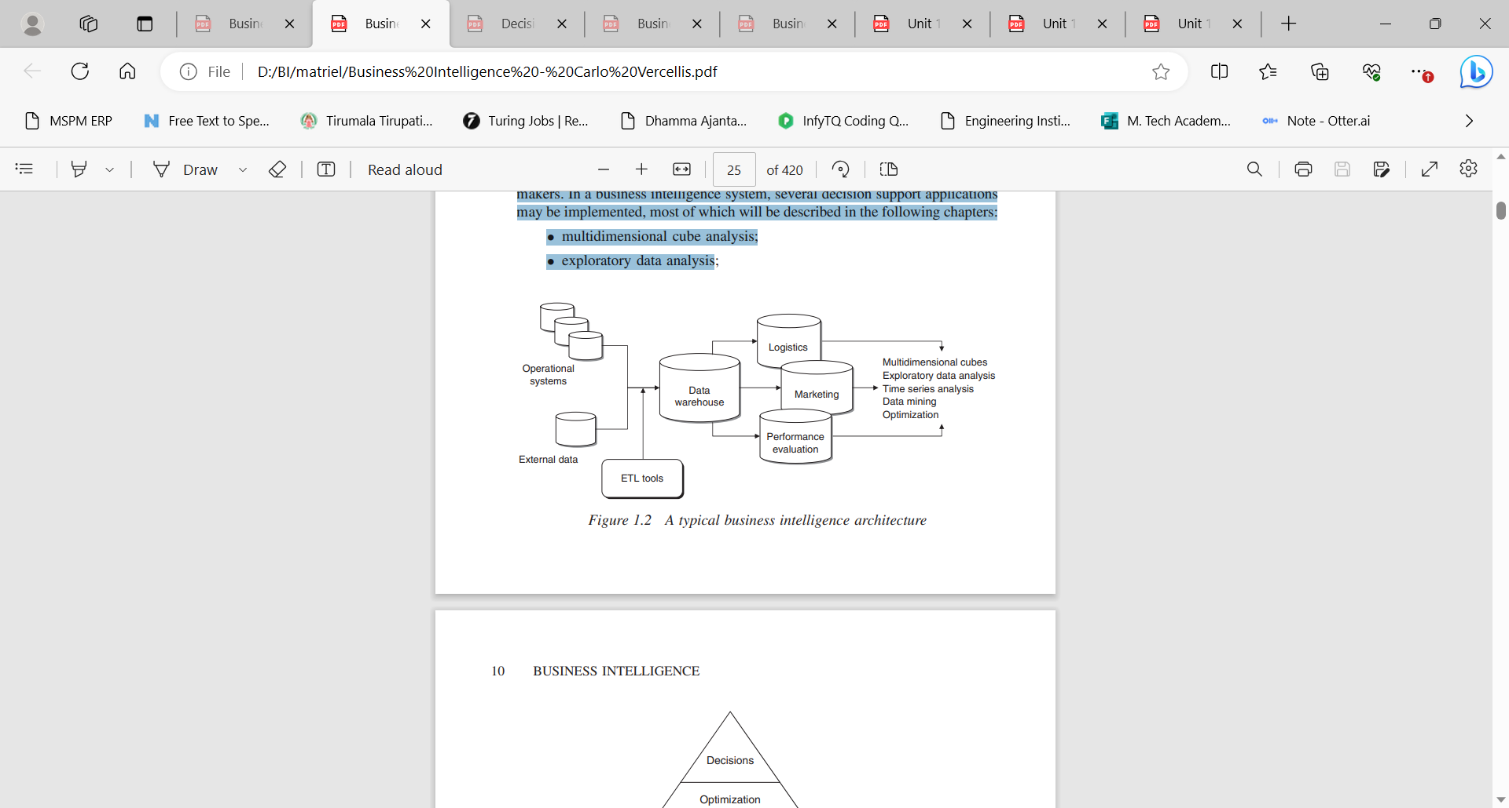

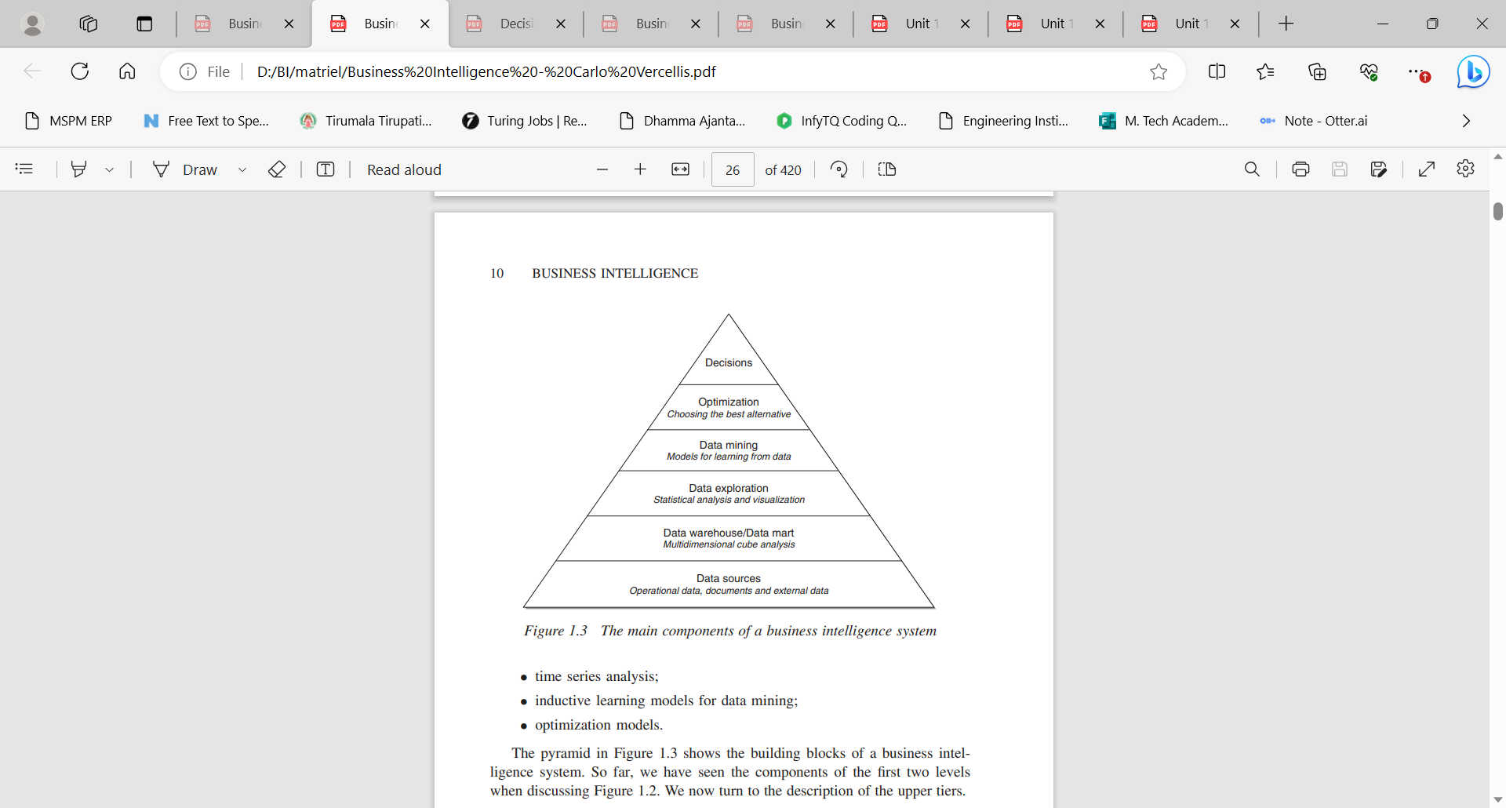

• time series analysis;

• inductive learning models for data mining;

• optimization models.

The pyramid in Figure 1.3 shows the building blocks of a business intelligence system. So far, we have seen the components of the first two levels

when discussing Figure 1.2. We now turn to the description of the upper tiers.

Data exploration. At the third level of the pyramid we find the tools for performing a passive business intelligence analysis, which consist of query and reporting systems, as well as statistical methods. These are referred to as passive methodologies because decision makers are requested to generate prior hypotheses or define data extraction criteria, and then use the analysis tools to find answers and confirm their original insight. For instance, consider the

sales manager of a company who notices that revenues in a given geographic area have dropped for a specific group of customers. Hence, she might want to bear out her hypothesis by using extraction and visualization tools, and then apply a statistical test to verify that her conclusions are adequately supported by data. Statistical techniques for exploratory data analysis will be described

Data mining. The fourth level includes active business intelligence methodologies, whose purpose is the extraction of information and knowledge from data. These include mathematical models for pattern recognition, machine learning and data mining techniques, which will be dealt with in Part II of this book.

Unlike the tools described at the previous level of the pyramid, the models of an active kind do not require decision makers to formulate any prior hypothesis to be later verified. Their purpose is instead to expand the decision makers’ knowledge. Optimization. By moving up one level in the pyramid we find optimization models that allow us to determine the best solution out of a set of alternative actions, which is usually fairly extensive and sometimes even infinite.

Example 1.2 shows a typical field of application of optimization models. Other optimization models applied in marketing and logistics will be described in Decisions. Finally, the top of the pyramid corresponds to the choice and the actual adoption of a specific decision, and in some way represents the natural conclusion of the decision-making process. Even when business intelligence methodologies are available and successfully adopted, the choice of a decision pertains to the decision makers, who may also take advantage of informal and

unstructured information available to adapt and modify the recommendations and the conclusions achieved through the use of mathematical models.

As we progress from the bottom to the top of the pyramid, business intelligence systems offer increasingly more advanced support tools of an active type. Even roles and competencies change. At the bottom, the required competencies are provided for the most part by the information systems specialists within the organization, usually referred to as database administrators. Analysts and experts in mathematical and statistical models are responsible for the

intermediate phases. Finally, the activities of decision makers responsible for the application domain appear dominant at the top.

As described above, business intelligence systems address the needs of different types of complex organizations, including agencies of public administration and associations. However, if we restrict our attention to enterprises, business intelligence methodologies can be found mainly within three departments of a company, as depicted in Figure 1.4: marketing and sales; logistics and production; accounting and control. The applications of business intelligence

described in Part III of this volume will be precisely devoted to these topics

**Cycle of a business intelligence analysis** Each business intelligence analysis follows its own path according to the application domain, the personal attitude of the decision makers and the available analytical methodologies. However, it is possible to identify an ideal cyclical

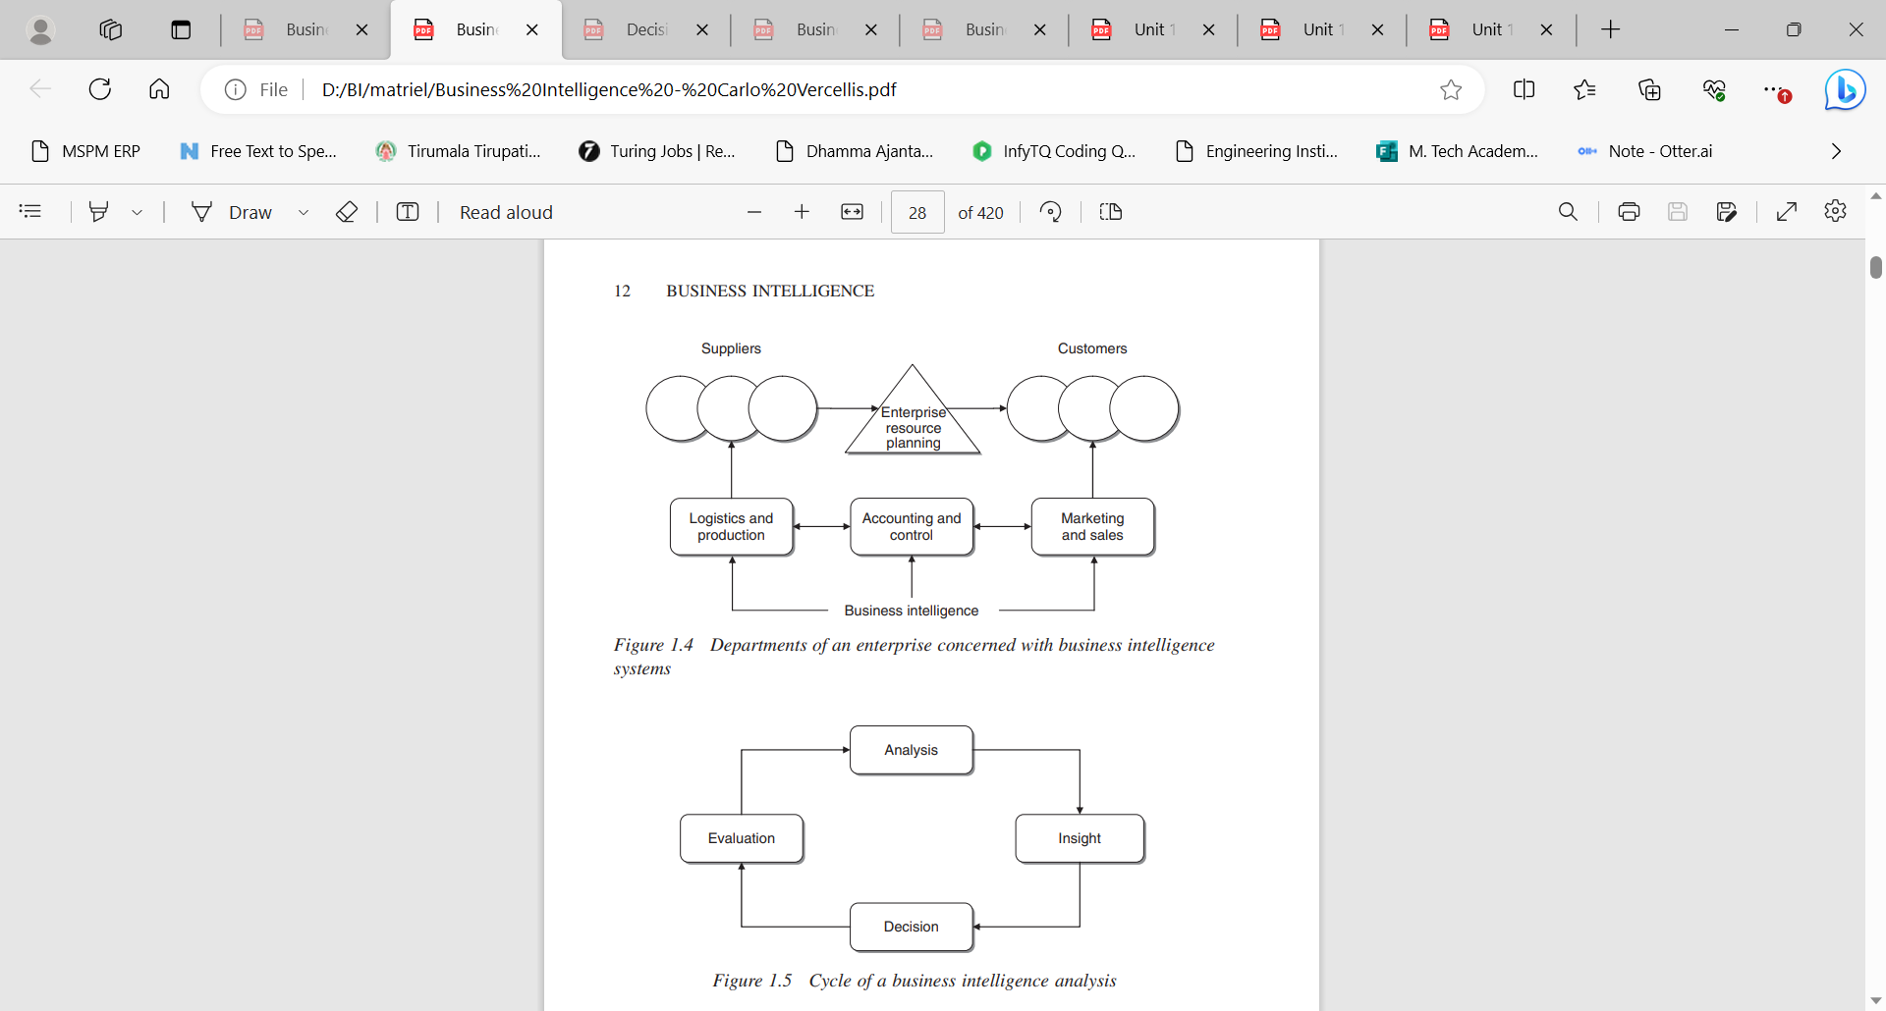

path characterizing the evolution of a typical business intelligence analysis, as shown in Figure 1.5, even though differences still exist based upon the peculiarity of each specific context. Analysis. During the analysis phase, it is necessary to recognize and accurately spell out the problem at hand. Decision makers must then create a mental representation of the phenomenon being analyzed, by identifying the critical factors that are perceived as the most relevant. The availability of business intelligence methodologies may help already in this stage, by permitting decision makers to rapidly develop various paths of investigation. For instance, the exploration of data cubes in a multidimensional analysis, according to different logical views as described in Chapter 3, allows decision makers to modify their BUSINESS INTELLIGENCE 13 hypotheses flexibly and rapidly, until they reach an interpretation scheme that they deem satisfactory. Thus, the first phase in the business intelligence cycle leads decision makers to ask several questions and to obtain quick responses in an interactive way. Insight. The second phase allows decision makers to better and more deeply understand the problem at hand, often at a causal level. For instance, if the analysis carried out in the first phase shows that a large number of customers are discontinuing an insurance policy upon yearly expiration, in the second phase it will be necessary to identify the profile and characteristics shared by such customers. The information obtained through the analysis phase is then transformed into knowledge during the insight phase. On the one hand, the extraction of knowledge may occur due to the intuition of the decision makers and therefore be based on their experience and possibly on unstructured information available to them. On the other hand, inductive learning models may also prove very useful during this stage of analysis, particularly when applied to structured data. Decision. During the third phase, knowledge obtained as a result of the insight phase is converted into decisions and subsequently into actions. The availability of business intelligence methodologies allows the analysis and insight phases to be executed more rapidly so that more effective and timely decisions can be made that better suit the strategic priorities of a given organization. This leads to an overall reduction in the execution time of the analysis–decision–action– revision cycle, and thus to a decision-making process of better quality. Evaluation. Finally, the fourth phase of the business intelligence cycle involves performance measurement and evaluation. Extensive metrics should then be devised that are not exclusively limited to the financial aspects but also take into account the major performance indicators defined for the different company departments. Chapter 15 will describe powerful analytical methodologies for performance evaluation.

**8)Summarize Effective and timely decisions on** **Business intelligence (L2:Understant)**

In complex organizations, public or private, decisions are made on a continual basis. Such decisions may be more or less critical, have long- or short-term effects and involve people and roles at various hierarchical levels. The ability of these knowledge workers to make decisions, both as individuals and as a community, is one of the primary factors that influence the performance and competitive strength of a given organization. knowledge workers reach their decisions primarily using easy and intuitive methodologies, which take into account specific elements such as experience, knowledge of the application domain and the available information. This approach leads to a stagnant decision-making style which is inappropriate for the unstable conditions determined by frequent and rapid changes in the economic environment. Indeed, decision-making processes within today’s organizations are often too complex and dynamic to be effectively dealt with through an intuitive approach, and require instead a more rigorous attitude based on analytical methodologies and mathematical models. The importance and strategic value of analytics in determining competitive advantage for enterprises has been recently pointed out by several authors, as described in the references at the end of this chapter. Examples 1.1 and 1.2 illustrate two highly complex decision-making processes in rapidly changing conditions. Example 1.1 – Retention in the mobile phone industry. The marketing manager of a mobile phone company realizes that a large number of customers are discontinuing their service, leaving her company in favor of some competing provider. As can be imagined, low customer loyalty, also known as customer attrition or churn, is a critical factor for many companies operating in service industries. Suppose that the marketing manager can rely on a budget adequate to pursue a customer retention campaign aimed at 2000 individuals out of a total customer base of 2 million people. Hence, the question naturally arises of how she should go about choosing those customers to be contacted so as to optimize the effectiveness of the campaign. In other words, how can the probability that each single customer will discontinue the service be estimated so as to target the best group of customers and thus reduce churning and maximize customer retention? By knowing these probabilities, the target group can be chosen as the 2000 people having the highest churn likelihood among the customers of high business value. Without the support of advanced mathematical models and data mining techniques, described in Chapter 5, it would be arduous to derive a reliable estimate of the churn probability and to determine the best recipients of a specific marketing campaign. Example 1.2 – Logistics planning. The logistics manager of a manufacturing company wishes to develop a medium-term logistic-production plan. This is a decision-making process of high complexity which includes, among other choices, the allocation of the demand originating from different market areas to the production sites, the procurement of raw materials and purchased parts from suppliers, the production planning of the plants and the distribution of end products to market areas. In a typical manufacturing company this could well entail tens of facilities, hundreds of suppliers, and thousands of finished goods and components, over a time span of one year divided into weeks. The magnitude and complexity of the problem suggest that advanced optimization models are required to devise the best logistic plan. As we will see in Chapter 14, optimization models allow highly complex and large-scale problems to be tackled successfully within a business intelligence framework. The main purpose of business intelligence systems is to provide knowledge workers with tools and methodologies that allow them to make effective and timely decisions. Effective decisions. The application of rigorous analytical methods allows decision makers to rely on information and knowledge which are more dependable. As a result, they are able to make better decisions and devise action plans that allow their objectives to be reached in a more effective way. Indeed, turning to formal analytical methods forces decision makers to explicitly describe both the criteria for evaluating alternative choices and the mechanisms regulating the problem under investigation. Furthermore, the ensuing in-depth examination and thought lead to a deeper awareness and comprehension of the underlying logic of the decision-making process. Timely decisions. Enterprises operate in economic environments characterized by growing levels of competition and high dynamism. As a consequence, the ability to rapidly react to the actions of competitors and to new market conditions is a critical factor in the success or even the survival of a company. Figure 1.1 illustrates the major benefits that a given organization may draw from the adoption of a business intelligence system. When facing problems such as those described in Examples 1.1 and 1.2 above, decision makers ask themselves a series of questions and develop the corresponding analysis. Hence, they examine and compare several options, selecting among them the best decision, given the conditions at hand. If decision makers can rely on a business intelligence system facilitating their activity, we can expect that the overall quality of the decision-making process will be greatly improved. With the help of mathematical models and algorithms, it is actually possible to analyze a larger number of alternative 6 BUSINESS INTELLIGENCE Business intelligence Many alternatives considered More accurate conclusions Effective and timely decisions Decision Decision Analysis and questions Alternative actions Analysis and questions Alternative actions ⇓ ⇓ Figure 1.1 Benefits of a business intelligence system actions, achieve more accurate conclusions and reach effective and timely decisions. We may therefore conclude that the major advantage deriving from the adoption of a business intelligence system is found in the increased effectiveness of the decision-making process.

